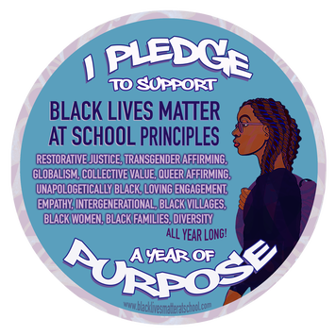
The Black Lives Matter Movement is guided by the following principles. We seek to expand student understanding of these principles through the week of action.
1. Restorative Justice
We are committed to collectively, lovingly, and courageously working vigorously for freedom and justice for Black people and, by extension, all people. As we forge our path, we intentionally build and nurture a beloved community that is bonded together through a beautiful struggle that is restorative, not depleting.​
2. Empathy
We are committed to practicing empathy; we engage comrades with the intent to learn about and connect with their contexts.
3. Loving Engagement
We are committed to embodying and practicing justice, liberation, and peace in our engagements with one another.
4. Diversity
We are committed to acknowledging, respecting, and celebrating difference(s) and commonalities.
5. Globalism
We see ourselves as part of the global Black family and we are aware of the different ways we are impacted or privileged as Black folk who exist in different parts of the world.​
6. Queer Affirming
We are committed to fostering a queer‐affirming network. When we gather, we do so with the intention of freeing ourselves from the tight grip of heteronormative thinking or, rather, the belief that all in the world are heterosexual unless s/he or they disclose otherwise.
​
7. Trans Affirming
We are committed to embracing and making space for trans siblings to participate and lead. We are committed to being self-reflexive and doing the work required to dismantle cis-gender privilege and uplift Black trans folk, especially Black trans women who continue to be disproportionately impacted by trans-antagonistic violence.
8. Collective Value
We are guided by the fact all Black lives matter, regardless of actual or perceived sexual identity, gender identity, gender expression, economic status, ability, disability, religious beliefs or disbeliefs, immigration status or location.
​
9. Intergenerational
We are committed to fostering an intergenerational and communal network free from ageism. We believe that all people, regardless of age, show up with capacity to lead and learn.
10. Black Families
We are committed to making our spaces family-friendly and enable parents to fully participate with their children. We are committed to dismantling the patriarchal practice that requires mothers to work “double shifts” that require them to mother in private even as they participate in justice work.
11. Black Villages
We are committed to disrupting the Western-prescribed nuclear family structure requirement by supporting each other as extended families and “villages” that collectively care for one another, and especially “our” children to the degree that mothers, parents and children are comfortable.
12. Unapologetically Black
We are unapologetically Black in our positioning. In affirming that Black Lives Matter, we need not qualify our position. To love and desire freedom and justice for ourselves is a necessary prerequisite for wanting the same for others.​
​
13. Black Women
​We are committed to building a Black women affirming space free from sexism, misogyny, and male‐centeredness.

